

JADAVPUR UNIVERSITY
Faculty of Engineering and Technology
Data Structures and Algorithms Laboratory
REPORT – ASSIGNMENT 1

Year: UG2 Batch: 2022 - 2026 Department: CSE Section: A3 Names: Debjit Dhar, Soham Lahiri
Roll Numbers: 002210501106, 002210501107

PROBLEM 1

PROBLEM STATEMENT
Write a program to compute the factorial of an integer n iteratively and recursively. Check when there is an overflow in the result and change the data types for accommodating higher values of inputs.

SOLUTION APPROACH
We approach the solution to the problem in two ways.
In the first way, we first assign an integer variable ‘ans’ a value of 1. Then in an iterative manner, we keep
on multiplying the values from 1 to n to ans. Thus ‘ans’ is storing n!.
In the second approach, we first call the factorial calculating function f with a value of n, then it calls the same function with a value of n-1 and it keeps on calling the same function until it hits a base case of n = 0.
After getting the value of f(n-1), we multiply n with f(n-1) to get f(n);

f(n) = n*f(n-1), for n>0 f(n) = 1, for n = 0

STRUCTURED PSEUDOCODE
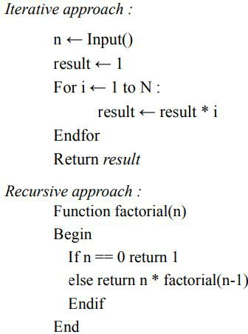

RESULTS

Data Type | Overflow at n =
int | 13
unsigned int | 13
long int | 21
unsigned long int | 21
long long int | 21
unsigned long long int | 21

** The result is the same for both the iterative method and the recursive method.

PROBLEM 2

PROBLEM STATEMENT
Write a program to generate the nth Fibonacci number iteratively and recursively. Check when there is an overflow in the result and change the data types for accommodating higher values of inputs. Plot the Fibonacci number vs n graph.

SOLUTION APPROACH
For calculating the nth Fibonacci number iteratively, we take 3 variables, a, b, and c, and initialize them as a = 0, b = 1, representing 1st and 2nd Fibonacci numbers. If n is less or equal to 2, we return n - 1. Else, we run a loop from i = 0 to i = n – 1, and in each iteration, we calculate c (representing (i + 1)th Fibonacci number in the ith iteration) as c = a + b and update a with the value of b and b with the value of c. At the end of the loop, we return c, representing the nth Fibonacci number.
For calculating the nth Fibonacci number recursively, we take our Base Case as: if n is less than or equal to 2, we return n - 1. Else according to the formula, Fibonacci(n) = Fibonacci(n - 1) + Fibonacci(n - 2), we recursively call the function for n - 1 and n - 2 and store their sum in ans and return ans.
We do these processes for data types: int, long int and long long int.

STRUCTURED PSEUDOCODE
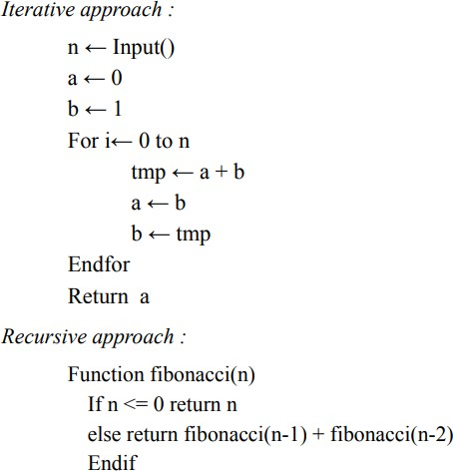

RESULTS
- By iterative method and using “unsigned long long int”, we get overflow at input 94. To calculate 93rd Fibonacci number it takes 0.000003 sec.
- By recursive method and using “unsigned long long int”, we cannot determine where it actually overflows. Because as we are increasing the input the time is increasing too much. The time taken by the program for last few inputs are –

Input | Time Taken [In sec]
45 | 7.001000
46 | 13.023570
47 | 19. 804000
48 | 37. 818000
49 | 59. 102000
50 | 97.056203
51 | 160.024000
52 | 229.378500

Plot of Fibonacci number vs n

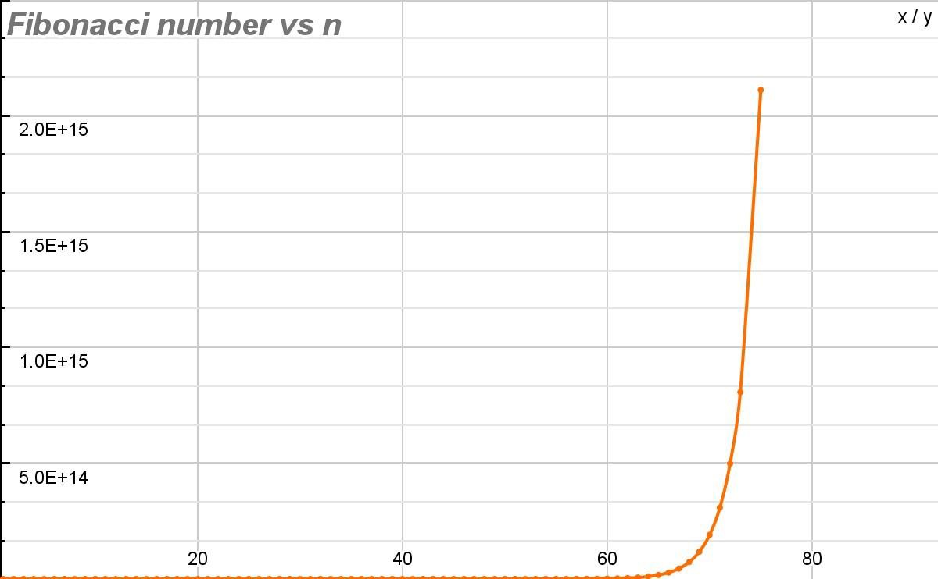

PROBLEM 3

PROBLEM STATEMENT
Write programs for linear search and binary search for searching integers, floating point numbers and words in arrays of respective types.

SOLUTION APPROACH

Linear Search:
- For integers: We iterate through the array by running a loop from i = 0 to i = size - 1 and check if the integer at ith index of the array is equal to the target integer, i.e. if (arr[i] == target), we return the index i. If the loop ends, that means we haven't found the target at any of the indices, so we return -1.

- For floating points numbers: We iterate through the array by running a loop from i = 0 to i = size - 1 and check if the absolute difference between the floating point number at ith index of the array and the target floating point number is less than or equal to the given tolerable error, i.e. if (fabs(arr[i] - target) <= error), we return the index i. If the loop ends, that means we haven't found the target at any of the indices, so we return -1.

- For words: We iterate through the array by running a loop from i = 0 to i = size - 1 and check if the value returned by strcpy function from the string.h header with the string at ith position of the array and the target string as arguments. If strcpy(arr[i], target) returns 0, that means target and arr[i] are the same strings, so we return the index i. If the loop ends, that means we haven't found the target at any of the indices, so we return -1.

Binary Search:
- For integers: We initialize two pointers: left (l) and right (r). l is initially at the start of the array and r is initially at the end of the array. The range [l, r] represents our search space. We run a loop until l crosses r (i.e. while l is towards the left of r). We calculate the mid index at the middle of l and r at each iteration. If the element at mid is less than target, that means target is towards right of mid, so we update our search space towards the right of mid by shifting l to mid + 1. Else if the element at mid is greater than target, that means target is towards left of mid, so we update our search

space towards the left of mid by shifting r to mid - 1. Else, the only case remaining is the element at mid is equal to target. So the target is found, print the mid index and return the mid index. If the loop is completed, it means we have iterated throughout the array but did not find the target, print not found and return -1.

- For floating point integers: We initialize two pointers: left (l) and right (r). l is initially at the start of the array and r is initially at the end of the array. The range [l, r] represents our search space. We run a loop until l crosses r (i.e. while l is towards the left of r). We calculate the mid index at the middle of l and r at each iteration. If the element at mid is less than target - error, that means target is towards right of mid, so we update our search space towards the right of mid by shifting l to mid + 1. Else if the element at mid is greater than target + error, that means target is towards left of mid, so we update our search space towards the left of mid by shifting r to mid - 1. Else, the only case remaining is that the element at mid is equal to target (within error, i.e. the absolute difference between the floating point number at mid index of the array and the target floating point number is less than or equal to the given tolerable error). So the target is found, print the mid index and return the mid index. If the loop is completed, it means we have iterated throughout the array but did not find the target, print not found and return -1.

- For words: We initialize two pointers: left (l) and right (r). l is initially at the start of the array and r is initially at the end of the array. The range [l, r] represents our search space. We run a loop until l crosses r (i.e. while l is towards the left of r). We calculate the mid index at the middle of l and r at each iteration. If (strcmp(arr[mid], target) < 0), that means element at mid is lexicographically smaller than target, so target is towards right of mid, so we update our search space towards the right of mid by shifting l to mid + 1. Else if (strcmp(arr[mid], target) > 0), that means element at mid is lexicographically greater than target, so target is towards left of mid, so we update our search space towards the left of mid by shifting r to mid - 1. Else if (strcmp(arr[mid], target) == 0), that means element at mid is lexicographically equal to target, So the target is found, print the mid index and return the mid index. So the target is found, print the mid index and return the mid index. If the loop is completed, it means we have iterated throughout the array but did not find the target, print not found and return -1.

STRUCTURED PSEUDOCODE
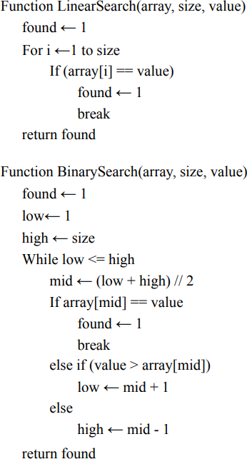

However, binary search works only on sorted arrays and not unsorted ones. So we require a sort function for smooth running of the program. Here, we use bubble sort.

PROBLEM 4

PROBLEM STATEMENT
Write a program to generate 1,00,000 random integers between 1 and 1,00,000 without repetitions and store them in a file in character mode one number per line. Study and use the functions in C related to random numbers.

SOLUTION APPROACH
To ensure there are no repetitions, we consider an array of 1,00,000 size. Initially, all the elements are “0” but as we randomly generate and write a number we assign that particular position as “1”. For further steps of processing, we check this value. If it’s “1” we don’t write that number. Like this we use a kind of a flag array for checking the presence of a number.

STRUCTURED PSEUDOCODE
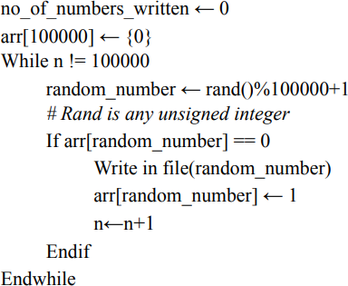

RESULTS:
It successfully writes all numbers from 1 to 1,00,000 in random_numbers.txt without any repetition.

Problem 5

PROBLEM STATEMENT
Write a program to generate 1,00,000 random strings of capital letters of length 10 each, without repetitions and store them in a file in character mode one string per line.

SOLUTION APPROACH
We consider a flag 2D character array of 100,000 rows and 10 columns. For each time we store each of the strings in each row. While checking for inclusion of a string we check each row, if it matches with the randomly generated string we don’t include that string. Also we consider a counter to count the number of strings written in the file.

STRUCTURED PSEUDOCODE
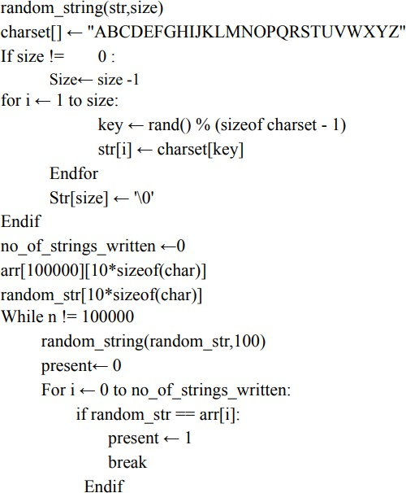

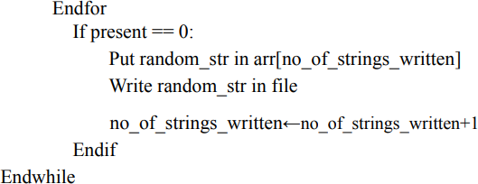

RESULTS:
It successfully writes 1,00,000 unique strings into the text file.

PROBLEM 6

PROBLEM STATEMENT
Store the names of your classmates according to roll numbers in a text file one name per line. Write a program to find out from the file, the smallest and largest names and their lengths in number of characters. Write a function to sort the names alphabetically and store in a second file.

SOLUTION APPROACH:
We first store the names in an array. We then sort this array and to find the largest and the smallest name we compare each element pairwise to find the largest and smallest name.

STRUCTURED PSEUDOCODE:
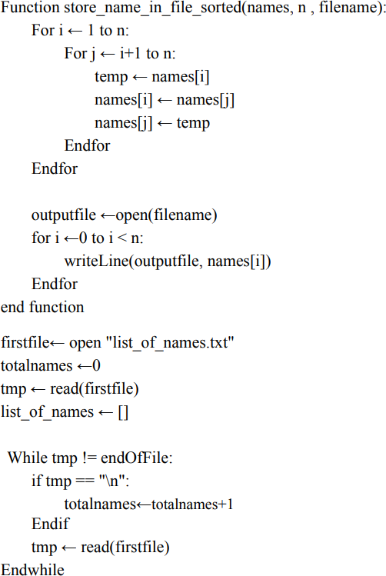

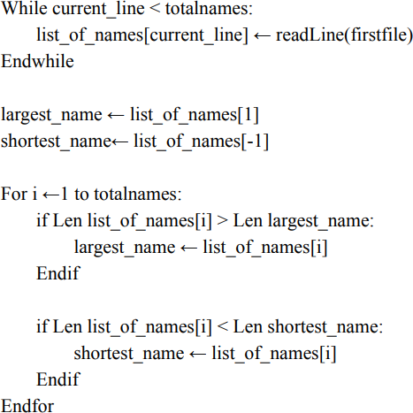

RESULTS
We get the smallest and the largest name according to their size and get the alphabetically sorted name list.

PROBLEM 7

PROBLEM STATEMENT
Take a four-digit prime number P. Generate a series of large integers L and for each member Li compute the remainder Ri after dividing Li by P. Tabulate Li and Ri. Repeat for seven other four digit prime numbers keeping Li fixed.

SOLUTION APPROACH
We generate a four digit prime by the following method:
- We generate a random 3 digit number by generating a random number and taking the remainder when its divided by 1000.
- We then generate a random one digit non zero number and multiply it by 1000 and add it to the 3 digit number.
- We check if the result is a prime. If not, we continue generating 4 digit numbers until we get a prime.
- We are checking if a number is a prime by dividing it by all integers less than or equal to its square root. If we find any remainder is 0, it is not prime. Else, it is prime.

We generate a large integer by the following method.
- We take the size of the large integer to be of 20 digits.
- We make an integer array of 10 X 20 size. Each row represents one large integer.
- We generate them by generating 20 non zero digits and ensuring the first one isn’t 0.

Now we divide each integer by each of the primes. We do this by implementing long division.
- Since the prime is of 4 digits, we take the 4 most significant digits of the long integer and convert it to the equivalent 4 digit integer.
- We divide this new integer by the prime, we take the remainder and append the next digit of the long integer to the remainder and continue dividing by the prime until all the 20 digits are used and remainder is taken. This is our final remainder.
- We print these remainders and store the primes in a file to be used in problem 8.

STRUCTURED PSEUDOCODE:
// function to check if a number is prime or not
isPrime(n):
if(n<2) return false; Initialize i = 2; DoWhile i * i <= n

If i divides n Return false
i++ EndDo
Return true

// function to generate 4-digit prime number
Initialize p = 1
DoWhile p is not a prime Initialize msd = 0
DoWhile msd is equal to zero msd = rand() % 10
EndDo
Initialize temp = rand() %1000 p = temp + 1000*msd
EndDo
save prime number p in an array

//function to generate large integers
Initialize i = 0, LargeInt DoWhile i<20
LargeInt = rand()%10 DoWhile(LargeInt is equal to 0) LargeInt = rand()%10
EndDo i++ EndDo

//function to convert 4 integers of large int array to actual 4-digit integer
Initialize i = 0, ans = 0, factor = 1000 DoWhile i<4
ans = ans + largeint[i + ind] * factor
// ind is the starting index of the LargeInt array
factor = factor/10 i++
EndDo

// function to print remainder using long division
Let p = prime divisior, n = the number we get by taking first 4 digits of large int array Initialize i = 4, rem = n%p
DoWhile i < 20 rem = rem *10
rem = rem + LargeInt[i] rem = rem % p
i++ EndDo print rem

RESULTS:
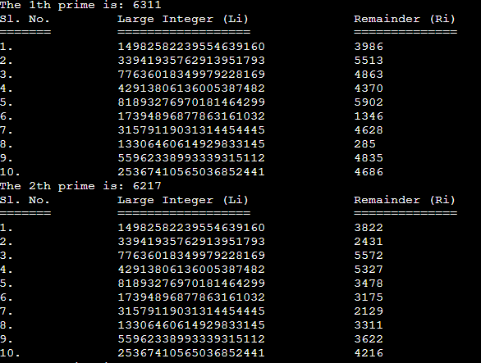

Also, a prime.txt file is created which stores the generated primes.

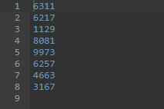

PROBLEM 8

PROBLEM STATEMENT
Convert your name and surname into large integers by juxtaposing integer ASCII codes for alphabet. Print the corresponding converted integer.
Cut the large integers into two halves and add the two halves.
Compute the remainder after dividing the result by the prime numbers P in the problem 7.

SOLUTION APPROACH
We take the full name of the user by input and will store that. We convert all alphabets of the string and store them in an array sequentially. We take two strings s1 and s2 and divide the previous string in two parts and store them in s1 and s2. Then s1 and s2 will be converted to integers and will sum up [say S]. And will divide S with every 4 digit prime number and print the result in the terminal.

STRUCTURED PSEUDOCODE:
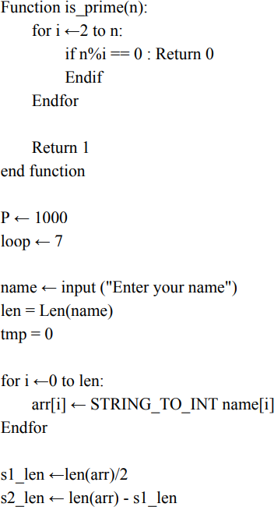

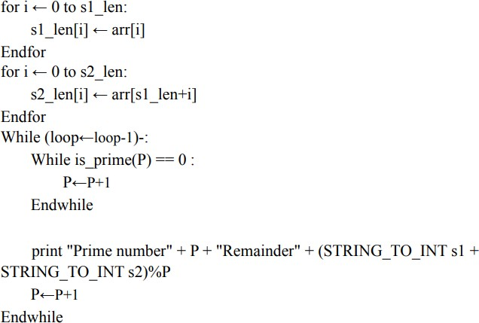

RESULTS:
We get the required remainder, for any given name.

PROBLEM 9

PROBLEM STATEMENT

Write a program to check whether a given number is perfect or not. If it’s a perfect number add 97 to each of its digits. Now consider the result as an ASCII series. Convert the same into equivalent character sequence.

SOLUTION APPROACH

At first we take input from the user. It is checked whether it’s a perfect number or not. If no then the control is returned to the main() otherwise 97 is added to each digit using a function and the corresponding character sequence is hence generated and returned to the main() as the final output.

STRUCTURED PSEUDOCODE

isPerfect(): Checks for a perfect number by the following method:
for(i=1;i<n;i++)
{
if(n%i==0) sum+=i;
}
If the sum equals n then it returns 1 else 0.
convertToArray(): We start the conversion from the end of the number since we will use % operation which extracts the last digit, then 97 is added to it to get the ASCII values and stored in an array after it has been typecasted to char explicitly. This array is then printed as the final output.

RESULTS:
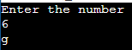

PROBLEM 10

Problem Statement
Write a program to find the maximum number of pieces that can be formed by making N cuts , where N is a positive integer.

Solution Approach:
maximum number of pieces that can be formed by making N cuts, pieces(n) can be given by the relation: pieces(n) = n + pieces(n - 1)

This can be proven by the Principle of Mathematical Induction.
- For n = 0, total number of pieces is 1.
- For n = 1, maximum number of pieces is 2.
- Now let us assume for n - 1 cuts, the maximum number of pieces is pieces(n - 1). So there are n - 1 cuts already present. Thus, the maximum number of cuts a new cut can encounter is n - 1. Now, when a cut encounters x number of cuts, it creates x + 1 new regions. So, when n - 1 cuts are made, n new regions are formed. This gives a total of n + pieces(n - 1) regions.

Structured Pseudocode:
Declare array cuts of n + 1 integers Initialise cuts[0] = 1
Initialise i = 1 DoWhile i <= n
Update cuts[i] with cuts[i-1]+i EndDo
Return cuts[n]

Results:
We get the maximum number of pieces by performing the given number of cuts.

PROBLEM 11

PROBLEM STATEMENT

Given a string and a string dictionary, write a program to find the longest string in the dictionary that can be formed by deleting certain characters of the given string. If there are more than one possible results return the longest word else return an empty string if none matches.

SOLUTION APPROACH

We get the lengths of given string and then go on comparing with the words of the dictionary. If a certain character will go unmatched then that word is skipped and we again restart checking for the given string for another word from the dictionary. In this way if a certain word can be totally found then we check if that is the longest word that can be formed out of the words in the dictionary and accordingly the result is printed.

STRUCTURED PSEUDOCODE

delete(): It is the function that settles the problem by checking the words from the dictionary and matching it with the given string(the one input by the user).
The major functioning works as follows
while (sp < slen && dp < dlen)
{
while (sp < slen && dp < dlen && s[sp] != dictionary[i][dp])
{
sp++;
}
sp++; dp++;
}
if (dp == dlen)
{
if (maxlen < dlen)
{
maxlen = dlen; maxind = i;

}
}
if (maxind >= 0)
{
return dictionary[maxind];
}
return "";
Hence we get the required output.

RESULTS:
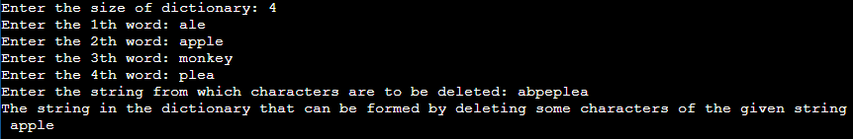

PROBLEM 12

PROBLEM STATEMENT
Given two strings(s and t) of lowercase alphabet and a value M.
write a program to detect if two strings are M-anagrams of each other or not. Two strings are called M-anagrams if the below conditions are true.
  - Both have same number of characters.
  - Two strings can become anagram by changing at most M characters in a string.
If the result is true , further find the minimum number of operations required to convert s to t. The list of permitted operations are:
  - Insert a character at any position of the string.
  - Remove any character from the string.
  - Replace any character from the string with any other character.
  - Shift any character to it's left or right position

SOLUTION APPROACH
We perform the different operations using different functions. One of them checks for M-Anagrams, the other performs the 4 said operations and there is another function that finds out the minimum number of steps required.

STRUCTURED PSEUDOCODE
swap(): It helps us to to do the required swapping operation without increasing the complexity of the operational function which thus helps in smooth running of the code.
Swapping occurs as:
char c = s[i]; s[i] = s[j]; s[j] = c;

minOperationToConvert(): For the base cases it checks if s1 and s are having the same required length then we have to work as:
if(i == l1)
return i-j; else if(j == l2)

return j-i;

Now, we intend to perform the operations as allowed by the problem. Right shift operation is performed as:
if((j+1)<=l2 && s1[i] == s2[j+1])
{
swap(s1,i,i+1);
a = 1 + minOperationToConvert(s1, s2,i+1,j+1,l1,l2); swap(s1,i,i+1);
}
Left shift operation is performed as:
else if((i+1)<=l1 && s1[i+1] == s2[j])
{

}
Deletion operation:
swap(s1,j,j+1);
b = 1 + minOperationToConvert(s1, s2,i+1,j+1,l1,l2); swap(s1,j,j+1);

c = 1 + minOperationToConvert(s1, s2,i+1,j,l1,l2);
Insertion operation:
d = 1 + minOperationToConvert(s1, s2,i,j+1,l1,l2);
Replacement operation:
e = 1 + minOperationToConvert(s1, s2,i+1,j+1,l1,l2);

Finally, the minimum number of operations required will always be the operations needed the least number of times. Hence we can make use of min() function to get the required ans as:

int ans = min(a,min(b,min(c,min(d,e))));

is_main_anagram(): In this function we get the length of the strings s1 and s2. Then we have two arrays that stores the frequency of characters in the two strings. Now we try to find the number of different characters present in the two strings such that if:
if (diff <= M)
return 1;

Thus we get M-Anagram checked.
else

return 0;

_Lab
RESULTS:

